Sandwood Primary School

Equality Policy

Promoting Equality and Diversity
Policy

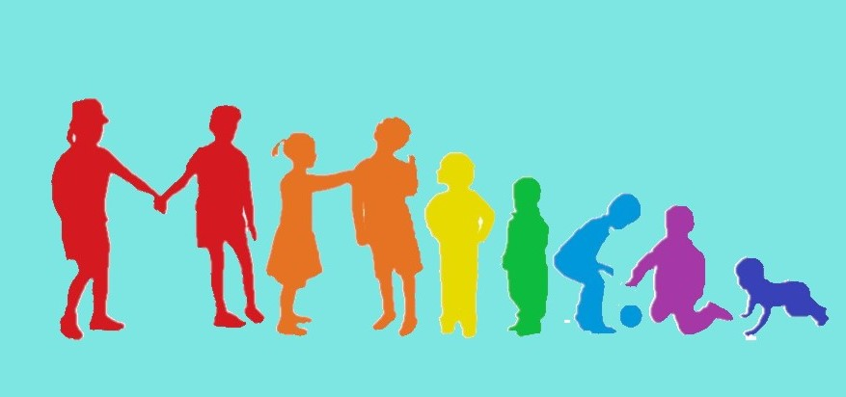

Rationale
Glasgow City Council Education Services is committed to equality and fairness, and our legal duties, obligations and associated responsibilities within the Equality Act 2010 across all our schools and early years establishments. We want to ensure that equality is embedded in all our establishments and that our values and cultures promote equalities. We want all our children and young people, staff, families and partners to feel highly valued and be treated fairly. We strive towards creating learning environments that reflect the diversity of the school community, both within the curriculum and in our workforce. We want everyone to have positive experiences and opportunities and recognise their contribution as global citizens to a world free from discrimination and one that promotes justice for all.

Our Equality policy seeks to ensure that are everyone regularly thinks about how they are taking forward equality in their roles and settings as a catalyst for positive change, equality and fairness. It will encourage all to reflect on their commitment, activities and culture and how to adapt to a continually changing and rapidly evolving society.

In taking forward our Equality policy we are continuing to support the aim of creating a nurturing school within a nurturing city where children and young people feel respected and included.

We want schools to continue to celebrate the diversity of communities across our city, to challenge ourselves and each other, and consider our actions and impact across all the protected characteristics. Fundamentally, we support Glasgow’s vision of a world class city with a thriving and inclusive economy where everyone can flourish.

Sandwood Primary School is committed to promoting a positive and diverse culture to which all staff, young people, families and the wider community are valued and supported irrespective of their age, disability, gender, race, religion or belief, sex, sexual orientation, marriage and civil partnership and pregnancy and maternity. We recognise our obligation under the Equality Act 2010 and are committed to promoting the equality and diversity of all that we work with.

Introduction
This policy sets out Sandwood Primary School’s approach to promoting equality, as defined within the Equality Act (2010). It covers age*, sex, race, disability, religion or belief, sexual orientation, pregnancy and maternity, and gender reassignment. This policy should be read in conjunction with other school policies and guidelines particularly the school’s anti-bullying policy, which should take account of the guidance in the Revised Anti Bullying Strategy 2019 [2Mb]. Our policy will set out how the school aims to remove barriers to learning for children and young people as individuals or groups.

Sandwood Primary School will adhere to the technical guidance on how to apply the Equality Act 2010 in Scottish schools as outlined in the following link; https://www.equalityhumanrights.com/en/publication-download/technical-guidance-schools-scotland

Our School Context
Sandwood Primary School was built in 1956 and is situated in Penilee, Glasgow. It is a non-denominational school providing Education for pupils from P1 – P7. We have a Co-located Language and Communication Resource within the school building. This resource joined the school in 2015 and has space to accommodate 30 pupils. Pupils attend the Language and Communication Resource from across the south of Glasgow and are allocated places by the City Inclusion group. Sandwood Primary School provides mainstream inclusion opportunities for the pupils who attend the Language and Communication Resource.
There are 31 members of teaching staff and 12 Support for Learning Workers across the establishment.
We currently have 341 pupils in total on our school roll. 44.9% of our families are in receipt of Free School Meals and 63.3% of our pupils are in SIMD 1&2.
We have a diverse range of families within the school with 43 pupils who have English as an Additional Language, speaking 16 different languages.

Aims and Values
The school is committed to provide equality and excellence for all in order to promote the highest possible standards.
The core values on which the policy is based include:
- a culture of respect for others
- promoting equality and social justice
- a community where pupils are well prepared for life in a diverse society
These align with the school’s vision and values which are;

Our Aim at Sandwood is:-
Dream, Believe, Achieve Together

This is underpinned by our Vision for our Pupils:
To promote a nurturing, inclusive ethos with high expectations, where everyone has the right to achieve, be respected, valued and celebrated.

Our Values help support our Vision and Aim:
Resilience
Effort
Success
Positivity
Equality
Caring
Teamwork

Our School’s overall approach to promoting Equality
Our school’s Equality Policy provides a framework to pursue its equality duties as outlined in the 2010 Equality Act. We will strive to take all reasonable steps to;

- eliminate unlawful discrimination, harassment and victimisation
- advance equality of opportunity between people who share a protected characteristic and people who do not share it
- foster good relations and positive attitudes between all characteristics and different groups

Through the Equality Policy, the school will seek to ensure that no children and young people, staff, parents, guardians or carers or any other person through their contact with the school receives less favourable treatment. This includes the protected characteristics identified within the Equality Act (2010) i.e. age*, sex, race, disability, religion or belief, sexual orientation, pregnancy, undergoing or who have undergone gender reassignment. This does not mean that all learners should be treated in exactly the same way: it means that we may need to deliver learning in a range of ways to meet the differing needs of people so that all receive the same standard of education as others as far as this is possible.
*(NB ‘age’ is also a protected characteristic but not in relation to pupils of any age in a school).
Appendix 3 – glossary of LGBT terms

The school seeks to:
  - promote understanding and engagement between communities
  - provide opportunities to engage their communities
  - encourage all children and families to feel part of the wider community
  - understand and respond to the needs and hopes of all our communities
  - tackle discrimination and inequality
  - increase life opportunities for all
  - ensure that learning, teaching and the curriculum explore and address issues of equality and social justice

We are committed to promoting and teaching about children and young people’s rights especially with Scotland incorporating the UNCRC into law.
There are a variety of activities and learning opportunities provided at Sandwood to develop our understanding of Diversity and Equality which are embedded within our Learning and Teaching Programmes. In addition, we also carry out the following:

- Sense Over sectarianism Project at P7 level
- Show Racism the Red Card P6
- Football partnership with Celtic & Rangers at P5
- EAL Committee
- Equalities Committee
- Rights Committee
- Inclusive School Committee
- British Sign Language Committee
- Focus on Black History Month
- Focus on Holocaust at upper stages
- Celebration of focus days: International Women’s day; Purple Friday; Autism Awareness Day; Dyslexia Awareness day etc
- Anti-bullying Week events
- EAL Coffee Mornings
- ASN Coffee Mornings
- Family Learning Café, Cooking sessions
- Recognition of Religious festivals
- Rights Respecting Schools Award gained at bronze level
- Working towards achievement of LGBT Charter - Silver Award

Roles and Responsibilities
The Headteacher is responsible for ensuring:
  - the policy is readily available and that, staff, children and young people and their parents/carers know about it
  - its procedures are followed
  - regular up to date information and data is uploaded to the establishment Education Perspective Report, annually
  - all staff know their responsibilities, including the Headteacher as leader of learning, and receive training and support in carrying these out
  - the school takes appropriate action in cases of harassment and discrimination and follows full procedures in line with SEEMIS Details of this are in Chapter 7 of Glasgow’s revised Anti-Bullying Strategy. Revised Anti Bullying Strategy 2019 [2Mb]
  - the school has appropriate channels and processes in place to encourage all voices to be listened to so that we can support children and young people’s confidence in reporting bullying incidents.

All school staff are responsible for:
  - promoting equality and a collaborative ethos in the classroom/playroom
  - developing school/class rules which challenge discriminatory behaviour
  - modelling good practice and being positive role models
  - proactively supporting learners if they face discrimination or inequalities linked to a protected characteristic
  - reporting discriminatory incidents following recording and reporting procedures as outlined in Chapter 7 of Revised Anti Bullying Strategy 2019 [2Mb]
  - recognise and tackle bias and stereotyping
  - promote equality and social justice
  - undertake CLPL opportunities to keep up to date with the law and practice on equality

Children and young people are responsible for:
  - supporting the school’s equality ethos
  - treating everyone in the school community with respect
  - supporting students who being treated unfairly, bullied and disrespected
  - sharing concerns or issues with a member of staff.

Parents/Carers are responsible for:
  - supporting the school’s equality ethos
  - sharing concerns or issues with senior staff
  - encouraging their children to uphold equality values and principles outside of the school environment

Partners and visitors are responsible for:
  - supporting the school’s equality ethos
  - sharing concerns or issues with senior staff

Responsibility for overseeing equality practices in the school lies with the Head Teacher
Responsibilities include:
  - co-ordinating and monitoring work on equality issues
  - dealing with and monitoring reports of harassment (including racist and homophobic incidents) through SEEMIS. For more details on how to take this forward please to refer to Education Services Anti-Bullying policy which is available at Glasgow Online
  - monitoring the progress and attainment of children and young people with protected characteristics
  - monitoring exclusions

Monitoring, Reviewing and Assessing Impact
  - The school’s Equality Policy is supported by actions in our School Improvement Plan. For 2021 – 2022 our priorities include a specific focus on Equalities and how this is embedded within our Learning & Teaching and in our philosophies. We have begun work on our LGBT Silver charter award, are progressing towards accreditation as a Language & Communication Friendly School (LCR).
  - The policy will be regularly monitored, reviewed and updated by all stakeholders to ensure that it is effective in eliminating discrimination, promoting access and participation, equality and good relations between different groups, and that it does not disadvantage particular sections of the community through use the ‘Equalities Self-Evaluation Tool’
  - Any pattern of inequality found as a result of self-evaluation will be used to inform future planning and decision-making
  - Progress in improving equalities in the school will be reported on in the school’s Quality and Standards Report
  - This policy links to other policies and in general the principles of equality will apply to all other school policies.

At Sandwood we strive to have Equality permeating throughout our Learning and Teaching approaches and evident in our school ethos to enable all our young people, families and staff to feel included, respected and recognised.

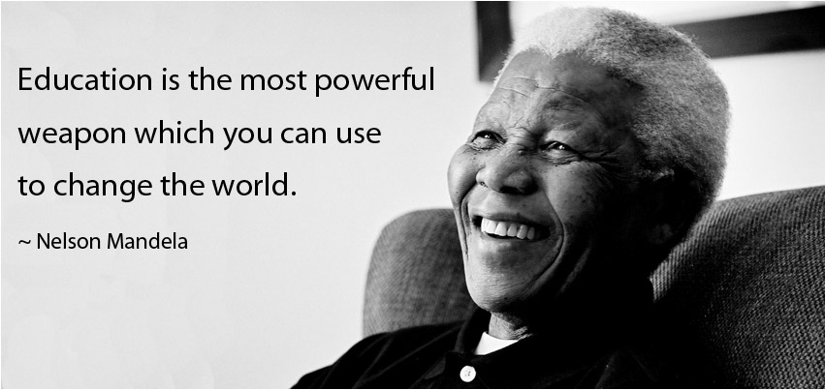
Equality Policy

Appendix 1

This information is collated and updated annually so that we can have a clear picture of the context of the school population. This will be used to contextualise our policy and ensure that it reflects the diversity of our school community.

SANDWOOOD PRIMARY SCHOOL - School Context (as at 28.2.22)

Details | Number | %
Staff (teaching and support staff) | 43
Sex
Male | 4 | 9
Female | 39 | 91%
Ethnicity/Race
White British/Scottish | 23 | 53%
White Other | 2 | 4.7%
Black and Minority Ethnic | 2 | 4.7%
Not known/disclosed | 16 | 37%
Disability (disclosed) | N/A | N/A
Children and Young People | 341
Sex
Male | 173 | 53%
Female | 154 | 47%
Ethnicity/Race
White British/Scottish | 232 | 73.6%
White other | 13 | 4.4%
Black and Minority Ethnic | 31 | 9.1%
Not known/disclosed | 51 | 12.9%
Additional Support Needs | 19 | 5.8%
EAL | 43 | 10.6%
Disability | 6 | 1.8%
Looked after/Care Experienced | 11 | 1.9%
SIMD 1&2 | 45 | 63.3%
FSM | 133 | 44.9%

Appendix 2 Resources, Organisations and Policies

https://www.equalityhumanrights.com/en/publication-download/technical-guidance-schools-scotland

- Revised Anti Bullying Strategy 2019 [2Mb].

www.crer.scot Coalition for Racial Equality and Rights

www.stephenlawrenceday.org Stephen Lawrence Foundation website

www.respectme.org.uk Anti-bullying service

www.tie.scot LGBT inclusive education charity

www.lgbtyouth.org.uk Supports LGBT young people

www.gda.scot Glasgow based charity run by and for disabled people

www.enableglasgow.org.uk Works with people in Glasgow with disabilities and their carers

www.glasgowwomensaid.org.uk Supporting women, children and young people experiencing domestic abuse

We will continue to add to this list over time.

Appendix 3 Glossary

THE PROUD TRUST
GLOSSARY

Everyone has the right to self-identify, and will have differing relationships with the words that people choose to identify themselves with. It is important to ask how a person identifies, and to respect their answer. Identities can be fluid and as life goes on, people often realise new things about themselves, and so the words that someone uses at one point in their life, may not be words that they will always identify with – and that’s totally ok! This glossary is not definitive, but below are some of the most common identities and terms used, when talking about sexual orientation (who you’re attracted to) and gender identity (how you feel about and see yourself.
Ally
A person who fights for, and supports others in their fight for equality, despite not being a member of the marginalised group, e.g. a heterosexual and/or cisgender person who believes in, and fights for equality, for LGBT+ people.

Aromantic
A person of any gender or sexual orientation who experiences little, or no, romantic attraction. Aromantic people may still experience other types of attraction, such as sexual or physical attraction.

Asexual
A person of any gender or sexual orientation who experiences little, or no, sexual attraction. Asexual people may still experience other types of attraction, such as physical or romantic attraction.

Bisexual
A person of any gender who experiences attraction to people of their own gender, and other genders.

Biphobia
Discrimination against and /or fear or dislike of bisexual people (including those perceived to be bisexual) or of bisexuality. This also includes the perpetuation of negative myths and stereotypes through jokes and/or through personal negative thoughts about bisexual people.

Cross Dresser
This word is usually used by men but can be used by a person of any gender, who dresses in clothes that are usually associated with a different gender.

Cis / cisgender
A person whose gender is the same or mostly the same as they were assigned at birth.

Cisnormativity
An emphasis on people being “the norm” if their gender identity and assigned gender at birth match, and therefore having a valued position in society. This often highlights and reinforces expected and more traditional ways of presenting your gender too e.g. the expectation for women to present as “feminine” and men to present as “masculine”.

Discrimination
Treating individuals or a particular group of people differently, especially in a worse way than how a person might generally treat others, because they hold negative views about people with certain characteristics - e.g. a person’s race, faith, sex assigned at birth, sexual orientation, class.

Gay
A man who is attracted to other men. Sometimes the word ‘gay’ is used by women who are attracted to women too.

Gender Expression
Refers to how a person externally presents their gender. This may be through choice of clothing, general physical appearance or social behaviour. Gender expression is most commonly/ traditionally measured on a scale of “masculinity” and “femininity”, although not always.

Gender Fluid
A person who feels that their gender is not static and that it changes throughout their life, this could be on a daily / weekly / monthly basis.

Gender Identity
How a person feels about and knows themselves to be. This might be as a woman, a man, as both, as neither, or in another way.

Gender Neutral/ Agender
A person who does not identity with any gender.

Gender Roles and Expectations
People are assigned a sex at birth and this often predetermines a gender role that a person is expected to fulfil e.g. someone assigned female at birth, will be expected to live, identify and outwardly present as a woman. There is also expectation to ‘act’ like a woman and carry out jobs that society deems appropriate for women. Gender roles and expectations are often reinforced by society, people around us and the media. People of all genders can find these expectations limiting and oppressive.

Heterosexism/ Heteronormativity
The assumption that everyone is heterosexual or straight, and that heterosexuality is superior, with an emphasis on heterosexuality being “the norm” and therefore having a valued position in society. The media often reinforces heteronormativity through images used and portrayal of character’s identities and attitudes.

Heterosexual/ Straight
A person who is attracted to people of a different gender e.g. a man who is only attracted to women.

Homophobia
Discrimination against and/or fear or dislike of lesbian and gay people (including those perceived to be gay or lesbian). This also includes the perpetuation of negative myths and stereotypes through jokes and/or through personal negative thoughts about lesbian and gay people.

Intersex
A person is assigned intersex, often at birth, when their sex characteristics don’t align with the medical definitions of “female” or “male”. A person’s external and internal body, as well as chromosomes and hormones, can all be factors when assigning sex.

Lesbian
A woman who is attracted to other women.

LGBTphobia
A term for the collective discrimination against and/or fear or dislike of LGBT+ people (including those perceived to be LGBT+). This also includes the perpetuation of negative myths and stereotypes through jokes and/or through personal negative thoughts about LGBT+ people.

LGBT+
An umbrella expression and an acronym for lesbian, gay, bisexual and trans (plus other related identities).

Non-binary
An umbrella term for gender identities which are not confined by the gender binary of “women” and “men”. Non-binary people may identify with no gender at all or with more than one gender.

Out/Coming Out
LGBT+ people living openly, and telling people about their sexual orientation and/or gender identity.

Pansexual
A person of any gender who is attracted to people of all genders.

Pronouns
Words used to refer to someone when their name isn’t used. They usually suggest a person’s gender, although some people prefer, or identify with, neutral pronouns. Common pronouns include her, she, him, he, they, them.

Queer
Historically this word was used as a negative insult, however many people feel they have reclaimed the word to have a positive meaning. Some people use it as a collective term for LGBT+ people, and some use it to explain their gender, sexual or political identity. Some people still use this word as an insult, this is LGBTphobia and should be challenged.

Questioning
A person who is uncertain about and/ or exploring their own sexual orientation and/or gender identity.

Sex Assigned at Birth
People are assigned a sex at birth, usually based on observation of external genitals. A person may be assigned “female”, “intersex” or “male”. However, this does not necessarily reflect how a person will identify themselves.

Sexual Orientation
The part of a person’s identity that describes who they experience attraction to, often but not always based on gender, e.g. lesbian, gay, bisexual, straight, pansexual.

Stereotype
A fixed idea that people have about what someone or something is like, often based on assumption and myth.

Trans / Transgender
A person whose gender identity is in some way different to the gender they were assigned at birth.

https://www.theproudtrust.org/wpcontent/uploads/downloadmanagerfiles/19.01%20Glossary%20of%20LGBT+%20Terminology.pdf

