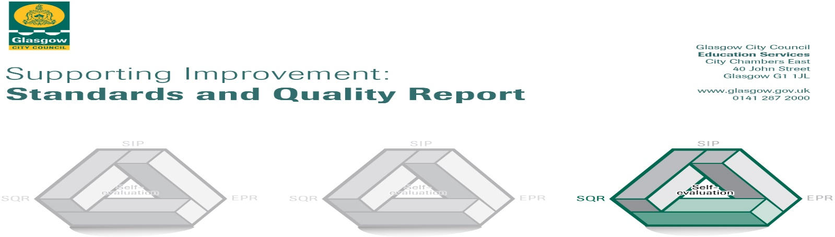The summary report is provided for parents/carers and partners to outline our achievements this session and our priorities for next session. Throughout this session we have taken forward our priorities as detailed in our school improvement plan. Through our processes of self-evaluation, we have identified how we can improve outcomes for our children and young people.

|  |  |
| --- | --- |
|  | **Our achievements and improvements this year.** |
| We would like to highlight the following improvements/achievements:  **Leadership of change – QI 1.3**   * Continued distributed Leadership across the school within Senior Leadership team, teaching staff and Support staff. * Almost all children across the school are included in a committee. * All teaching staff use Digital devices (iPads) to enhance learning. * Vision, Values and Aims embedded in all aspects of school life. * Continued focus on the widening of pupil voice initiative. * Continued focus on Reading, Writing and Listening & Talking and Numeracy & Mathematics has maintained attainment for almost all pupils. * Language and Communication Friendly Establishment Award – LCR May 2025 * Rights Respecting Schools Silver Award achieved June 2025. * Maintained grading by authority of very good.   **Learning teaching and assessment – QI 2.3**   * Almost all staff employ consistency of approach of skills pathways. * Almost all staff have received training on Adaptive Teaching through Glasgow’s Pedagogy. * Almost all staff are utilising digital technologies to support access to the curriculum and support ASN. * Most pupils are demonstrating an Improved ability to engage with digital learning through wider use of apps and digital technologies. * Shared understanding of approaches in Numeracy further developed through moderation activities within Learning Community. * All staff are employing creative approaches throughout learning. * All staff are developing art skills at all stages and showcasing pupil’s artwork in Creativity Corridor. * Robust tracking and assessment procedures in place, giving more detailed data to further inform targeted support required for all pupils. * All teaching staff in LCR trained in Makaton. * Personalisation and choice permeates throughout almost all aspects of learning. * Maintained rating by authority of very good.   **Well-being, equality and inclusion – QI 3.1**   * All staff are aware of their statutory requirements and codes of practice and engage in annual training on child protection, supporting care experienced learners and meeting learners’ needs. * Enhanced Nurture approaches from all staff are providing targeted wellbeing support to identified pupils * Creative and adaptive supports and timetabling in place to respond to the wide and varied needs and presentation of most pupils within school. * Almost all staff have received Asthma awareness training, and almost all pupils received asthma workshops as part of our focus on disabilities which has led to an enhanced understanding of the condition and how to support people with asthma. * Almost all staff received training on epilepsy and identified staff have received training on diabetes which is supporting our pupils with these medical conditions to be included within life of the school. * All teaching staff engaged in professional reading focussing on dyslexia which informed professional dialogue about our approaches to supporting pupils with dyslexia and our next steps in this area. * Maintained grading by authority of very good. |

|  |  |
| --- | --- |
|  | **Here is what we plan to improve next year.** |
| 1. **Grand Challenge - Wellbeing & Learning**   **Mission – Equalities**  **Commitments:**   * Embed Trauma Informed Practices. * Focus on Disability and Anti-Racism. * Further develop Makaton within LCR and wider school.  1. **Grand Challenge - Achievement & Progress**   **Mission – Further Develop Creative approaches.**  **Commitments:**   * Glasgow’s Pedagogy – raise awareness of metacognition/ meta skills. * Creativity – development of drama. * Planning & Assessment – adapt planning and assessment approaches.  1. **Grand Challenge – Connected Learning**   **Mission – Improve use of technology across the curriculum.**  **Commitments:**   * Monitoring & Tracking Tool. * Implement Digital Ambassadors Programme. * Further develop use of iPad applications. * Undertake Digital Discourse Training. |

|  |  |
| --- | --- |
|  | **How can you find out more information about our school?** |
| Please contact us directly if you require further information or if you wish to comment on the report.  The contact e-mail address is: Headteacher1108@sandwood-pri.glasgow.sch.uk  Our telephone number is:0141 883 8367  Our school address is:120 Sandwood Road, Glasgow, G52 2QY  Further information is available in: newsletters, the school website, and the school handbook  [www.sandwood-pri.glasgow.sch.uk](http://www.sandwood-pri.glasgow.sch.uk) |

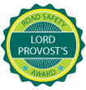

**Dream, Believe, Achieve Together**

